Ideation Phase
Empathize & Discover

Date
Team ID
Project Name
Maximum Marks

Empathy Map Canvas:
An empathy map is a simple, easy-to-digest visual that captures knowledge about a user’s behaviours and attitudes.

The empathy map shows that retail managers and business owners need a smarter way to analyze customer behavior, sales trends, and product performance. They face challenges such as poor product placement, low sales, and inefficient inventory management. By implementing Strategic Product Placement Analysis, they can gain actionable insights, optimize product placement, improve customer satisfaction, and make informed business decisions that lead to increased sales and profitability.
Example:
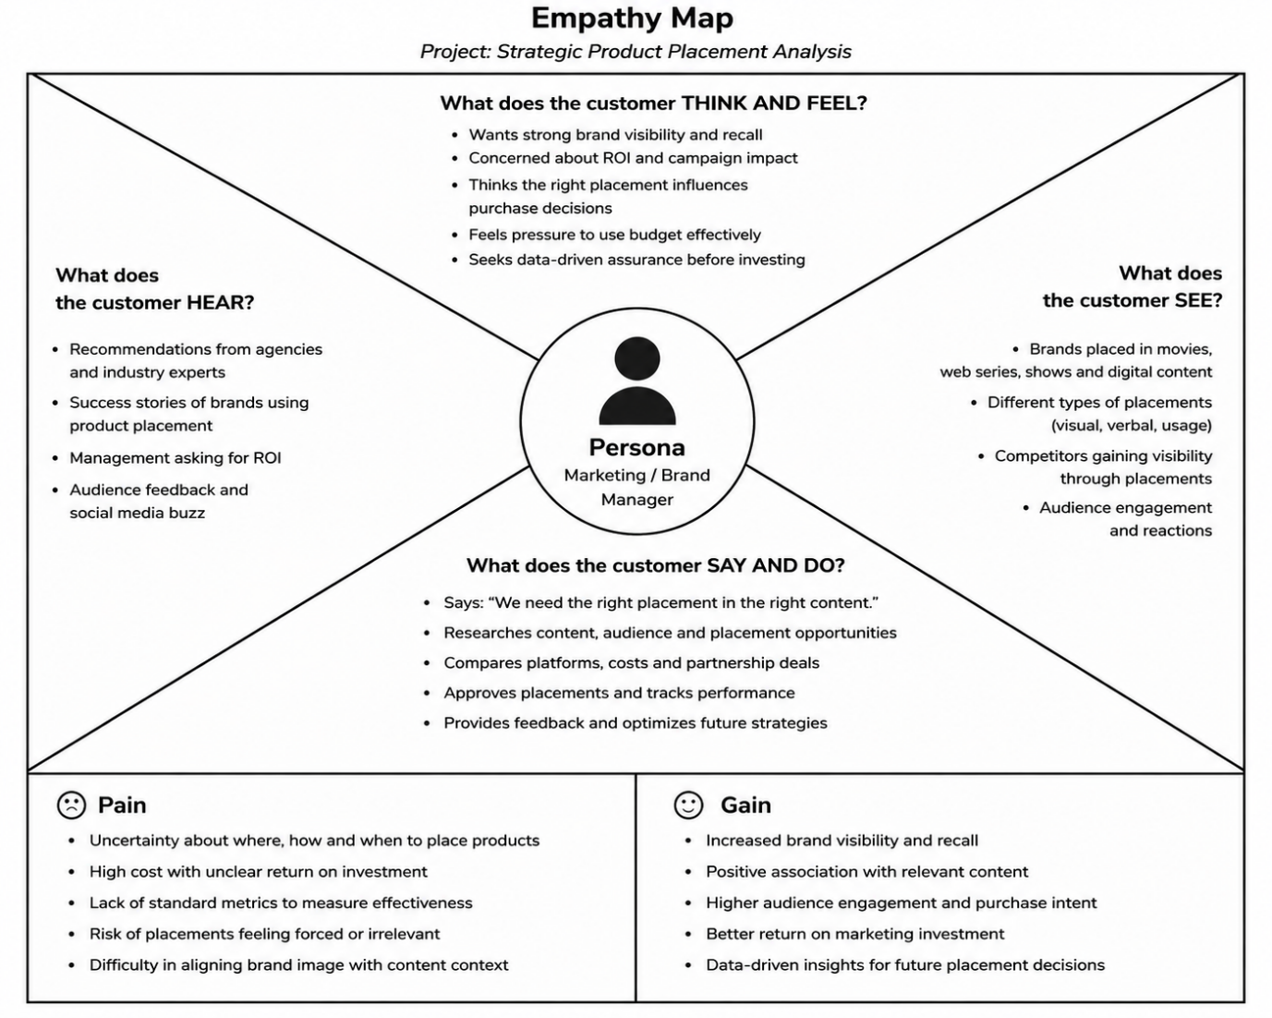

Reference: https://www.mural.co/templates/empathy-map-canvas

Example: Brands in Movies & OTT Platforms
